**DAILY ONLINE ACTIVITIES SUMMARY**

|  |  |  |  |  |  |  |  |  |
| --- | --- | --- | --- | --- | --- | --- | --- | --- |
| **Date:** | **30/05/2020** | | | | | **Name:** | **Kanaka BS** | |
| **Sem & Sec** | **6th & A** | | | | | **USN:** | **4al17cs039** | |
| **Online Test Summary** | | | | | | | | |
| **Subject** | | **PAP 2 IA test** | | | | | | |
| **Max. Marks** | | **30** | | **Score** | | | **12** | |
| **Certification Course Summary** | | | | | | | | |
| **Course** | **Complete Python Developer in 2020** | | | | | | | |
| **Certificate Provider** | | | **Udemy** | | **Duration** | | | **30 hours** |
| **Coding Challenges** | | | | | | | | |
| **Problem Statement:** executed | | | | | | | | |
| **Status: Solved** | | | | | | | | |
| **Uploaded the report in Github** | | | | | **yes** | | | |
| **If yes Repository name** | | | | | <https://github.com/kanakabs/Daily-Status> | | | |
| **Uploaded the report in slack** | | | | | **yes** | | | |

IA TEST

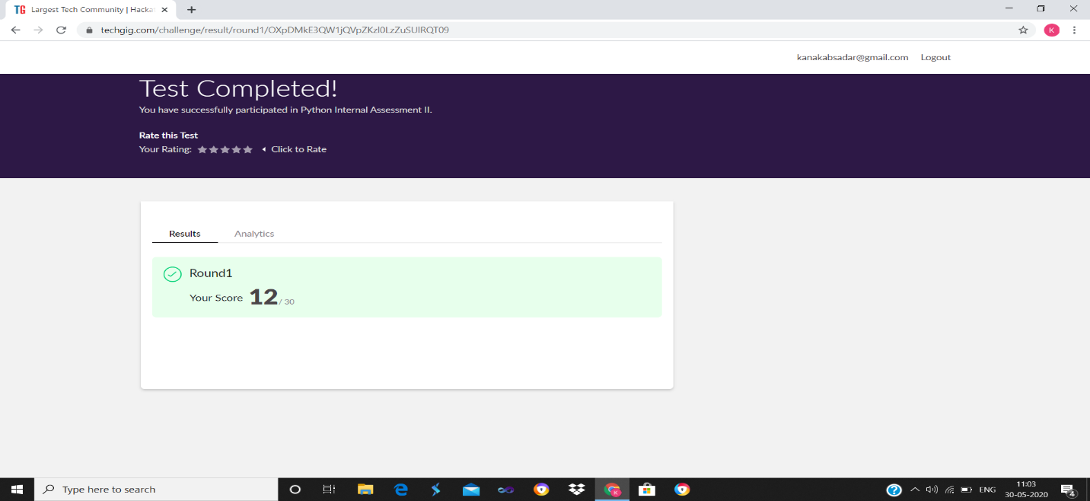

CERTIFICATION COURSE

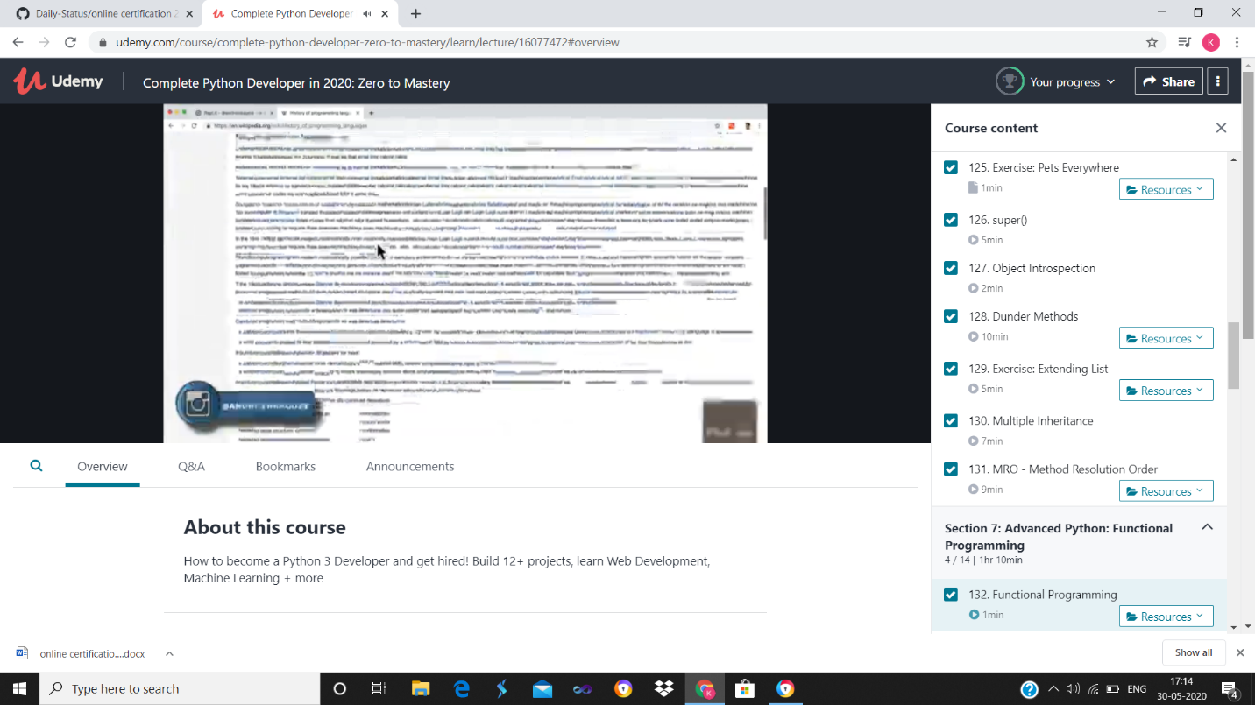

ONLINE CODING

Program output:

P1

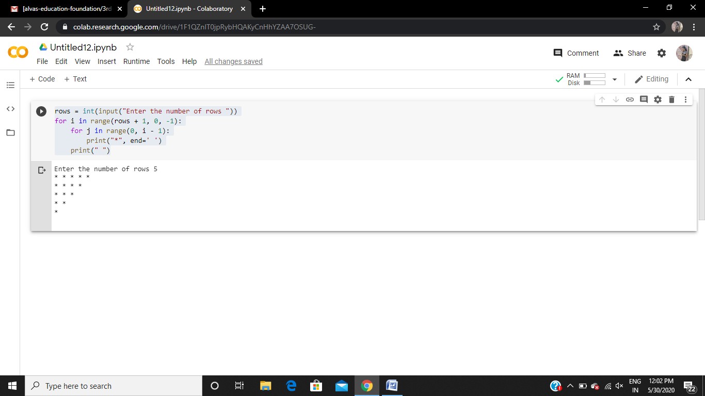

P2

